ISMCR 2022 Tutorial Proposal

Intelligent Analysis of Data with Robotic Application in Perception of the Workspace
Trung T. Pham
United States Air Force Academy, Colorado, USA

Extended Abstract
Data has always been an integral component of engineering applications where sensors are used to provide some aspect of the external environment so that an engineering system can function in some automatic capability that it is operating in that environment. Sensor data has been used as direct feedback to an engineering system to provide automatic control to maintain that system at a certain desired level. As engineering systems evolve to be smarter, they normally require a more complex interpretation of the external workspace that they are operating in and the sensor data of the past measuring some aspects of this workspace might not be sufficient for spontaneous tasks that require more interaction with a workspace that is fast changing in some unpredictable manner.
This tutorial session presents an intelligent approach to analyze sensor data for an engineering system to use deliberately. The analysis is framed in the context of data mining with the objective of automatically discovering knowledge from a given set of (numerical) data. In this aspect, it is assumed that the data set is large that it cannot be manually analyzed and its content is complex that it cannot be used in a simple feedback control loop. In general, data are obtained in the form of a large set of numerical data; and this data set is analyzed so that conceptual information can be discovered. This analysis process consists of four sequential stages: segmentation (to identify subsets of data with similarity), extraction (to identify characteristics of each data subset), representation (to model the characteristics of a data subset into specific format), and compaction (to minimize the form of the representation).
The first stage of segmentation is normally done computationally and automatically with a computer. Various algorithms are presented with simple examples done by commercially available software (specifically in this tutorial session, SPSS). The objective of understanding these algorithms is for the users to better select one that works for a specific application. Other stages of extraction, representation, and compaction are also presented, with emphasis on using computer software to aid human who still has to be in the loop to make the final decision on the output of each of the stages. Simple arbitrary numerical examples are given to demonstrate the complete process and to instill interested parties to confirm their understanding.
Various engineering applications of this analysis process are given in the task of automating the operation of a fleet of (inexpensive) drones in a search and rescue mission. In this endeavor, the environment is observed with sensors scanning distance from each drone to the target of the search. These sensor data will be used together to coordinate these drones to search for specific coordinates of the target, and as the drones are closing in to the target, digital cameras are used to visually and automatically confirm that the target is identified. This confirmation consists of three parts: confirming the identification of the target, confirming the coordinates of the target, and confirming the continuous tracking of the target so that a rescue mission can be mounted to pick up the target and transfer it to safety.

About the Presenter
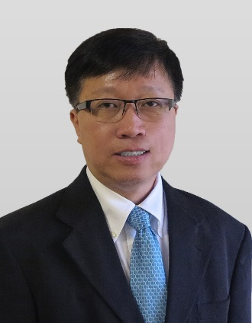
Dr. Trung Pham is currently at the United States Air Force Academy (USAFA) in Colorado, working as an academic professor, teaching in the Department of Computer & Cyber Sciences, and conducting research & development in AI & Machine Learning applications for the US Air Force Cyberworx (Center of Innovation in Cyber Security) where he was granted the US Top Secret Security Clearance. Previously he taught Control Theory, AI, and Neural Networks at the University of Houston, and was a technical specialist and staff engineer at NASA Johnson Space Center working in the area of Automation & Robotics in the Space Station Program. He also spent a stint at the University of Talca in Chile, South America as a visiting professor and director of the Center of Research in Information Technology, teaching computer sciences, and directing two nationally sponsored R&D projects on product authentication with embedded double-encryption in RFID and data mining on the IoT authentication activities. While in Chile, he also received the US State Department’s Fulbright Funding for a project on using swarm intelligence for coordinating a fleet of inexpensive drones to detect forest fire.
Dr. Pham is a Senior Member of the Institute of Electrical and Electronic Engineering (IEEE) and a Senior Member of the International Society of Automation (ISA). He is also an active member of the Technical Committee on Measurement in Robotics, and a Distinguished Speaker in the International Measurement Confederation (IMEKO).
Dr. Pham obtained his B.S.E.E. (Rice Endowment Scholarship, Texas Valedictorian Scholarship, and the Welsh Foundation Scholarship), M.S. (Office of Naval Research Fellowship), and Ph.D. (The National Aeronautic & Space Administration Fellowship) from the Department of Electrical & Computer Engineering at Rice University in Houston, Texas; and his M.B.A. (McDonnell Douglas Scholarship) from the University of Houston – Clear Lake in Houston, Texas.

